Лабораторная работа №5

Тема приложения: Афиша музыкальных мероприятий «Aura»
Структура5/
├── assets/
│ ├── Applemusic.svg
│ ├── Aura.svg
│ ├── dzhinniDOG.jpg
│ ├── fallinginreverce.jpg
│ ├── ksd.jpg
│ ├── lazzy.jpg
│ ├── martaDOG.jpg
│ ├── marylimmanson.jpg
│ ├── monaDOG.jpg
│ ├── share.svg
│ ├── slavakpss.jpg
│ ├── spotify.svg
│ ├── ymusic.svg
│ ├── zhuzhaDOG.jpg
│ ├── ава.jpg
│ └── юг.jpg
├── css/
│ ├── event.css
│ ├── event.min.css
│ ├── profile.css
│ ├── profile.min.css
│ ├── style.css
│ └── style.min.css
├── js/
│ └── event.js
├── fallinginreverse.html
├── index.html
├── marylinmanson.html
├── profile.html
└── slavakpss.html
index.html:
<!DOCTYPE html>
<html lang="en">
<head>
<meta charset="UTF-8">
<meta name="viewport" content="width=device-width, initial-scale=1.0, maximum-scale=1.0, user-scalable=no">
<title>Aura</title>
<link rel="stylesheet" href="https://cdnjs.cloudflare.com/ajax/libs/normalize/8.0.1/normalize.min.css">
<link rel="stylesheet" href="https://cdnjs.cloudflare.com/ajax/libs/font-awesome/6.5.1/css/all.min.css">
<link rel="stylesheet" href="css/style.min.css">
</head>
<body>
<header class="site-header">
<div class="header-top">
<a href="index.html" class="logo-mark" aria-label="Aura">
<img src="assets/Aura.svg" alt="Aura">
</a>
<nav aria-label="Main">
<ul class="header-icons">
<li>
<a href="profile.html" aria-label="Profile">
<i class="fa-regular fa-user"></i>
</a>
</li>
<li>
<a href="#" aria-label="Favorite events">
<i class="fa-regular fa-heart"></i>
</a>
</li>
<li>
<a href="#" aria-label="Questions">
<i class="fa-solid fa-question"></i>
</a>
</li>
</ul>
</nav>
</div>
<nav aria-label="Event period">
<ul class="period-tabs">
<li><a href="#" class="active">today</a></li>
<li><a href="#">tomorrow</a></li>
<li><a href="#">for a week</a></li>
<li><a href="#">soon</a></li>
</ul>
</nav>
<form class="search-bar" role="search" onsubmit="return false;">
<i class="fa-solid fa-magnifying-glass search-icon"></i>
<input type="search" placeholder="Search" aria-label="Search events">
</form>
</header>
<main>
<section aria-label="Featured event">
<a class="event-card-wrapper" href="slavakpss.html" style="--card-bg: url('assets/slavakpss.jpg');">
<article class="event-card event-card--hero">
<div class="event-card__image">
<img src="assets/slavakpss.jpg" alt="Slava KPSS — KATAFALKA">
</div>
<div class="event-card__content">
<div class="event-card__header">
<h2 class="event-card__title">Slava KPSS</h2>
<span class="event-card__title">16+</span>
</div>
<div class="event-card__desc">
<p>super anti-hype, the only rapper, gnoin-marmalade and just cute Russian almost Soviet concert</p>
</div>
</div>
</article>
</a>
</section>
<section class="events-grid" aria-label="Upcoming events">
<a class="event-card-wrapper event-card--small" href="marylinmanson.html" style="--card-bg: url('assets/marylimmanson.jpg');">
<article class="event-card">
<div class="event-card__image">
<img src="assets/marylimmanson.jpg" alt="Marilyn Manson">
</div>
<div class="event-card__content">
<div class="event-card__header">
<h3 class="event-card__title">Marilyn Manson</h3>
</div>
<div class="event-card__desc">
<p>Gothic rock concert</p>
</div>
</div>
</article>
</a>
<a class="event-card-wrapper event-card--small" href="fallinginreverse.html" style="--card-bg: url('assets/fallinginreverce.jpg');">
<article class="event-card">
<div class="event-card__image">
<img src="assets/fallinginreverce.jpg" alt="Falling in Reverse">
</div>
<div class="event-card__content">
<div class="event-card__header">
<h3 class="event-card__title">Falling in Reverse</h3>
</div>
<div class="event-card__desc">
<p>Alternative rock</p>
</div>
</div>
</article>
</a>
</section>
</main>
</body>
</html>

profile.html:
<!DOCTYPE html>
<html lang="en">
<head>
<meta charset="UTF-8">
<meta name="viewport" content="width=device-width, initial-scale=1.0, maximum-scale=1.0, user-scalable=no">
<title>Your profile — Aura</title>
<link rel="stylesheet" href="https://cdnjs.cloudflare.com/ajax/libs/normalize/8.0.1/normalize.min.css">
<link rel="stylesheet" href="https://cdnjs.cloudflare.com/ajax/libs/font-awesome/6.5.1/css/all.min.css">
<link rel="stylesheet" href="css/profile.min.css">
</head>
<body>
<header class="profile-header">
<a href="index.html" class="logo-mark" aria-label="Aura">
<img src="assets/Aura.svg" alt="Aura">
</a>
<nav aria-label="Main">
<ul class="header-icons">
<li>
<a href="profile.html" aria-label="Profile">
<i class="fa-regular fa-user"></i>
</a>
</li>
<li>
<a href="#" aria-label="Favorite events">
<i class="fa-regular fa-heart"></i>
</a>
</li>
<li>
<a href="#" aria-label="Questions">
<i class="fa-solid fa-question"></i>
</a>
</li>
</ul>
</nav>
</header>
<main class="profile-page">
<h1 class="profile-title">Your profile</h1>
<section class="profile-card">
<div class="profile-card__avatar">
<img src="assets/ава.jpg" alt="OleGGik">
</div>
<div class="profile-card__info">
<h2 class="profile-name">OleGGik</h2>
<p class="profile-username">@oleGGik</p>
</div>
</section>
<section class="favorite-conserts">
<h2 class="favorite-conserts__title">Favorite conserts:</h2>
<div class="favorite-conserts__list">
<div class="consert-card">
<div class="consert-card__image">
<img src="assets/юг.jpg" alt="404">
</div>
<div class="consert-card__meta">
<span class="consert-card__name">404</span>
<span class="consert-card__date">26.07.2026</span>
</div>
</div>
<div class="consert-card">
<div class="consert-card__image">
<img class="consert-card__image--lazzy" src="assets/lazzy.jpg" alt="Lazzy2Wice">
</div>
<div class="consert-card__meta">
<span class="consert-card__name">lazzy2wice</span>
<span class="consert-card__date">13.05.2026</span>
</div>
</div>
<div class="consert-card">
<div class="consert-card__image">
<img class="consert-card__image--ksd" src="assets/ksd.jpg" alt="Конец солнечных дней">
</div>
<div class="consert-card__meta">
<span class="consert-card__name">конец солнечных дней</span>
<span class="consert-card__date">24.12.2025</span>
</div>
</div>
</div>
</section>
</main>
</body>
</html>

fallinginreverse.html:
<!DOCTYPE html>
<html lang="en">
<head>
<meta charset="UTF-8">
<meta name="viewport" content="width=device-width, initial-scale=1.0, maximum-scale=1.0, user-scalable=no">
<title>Aura</title>
<link rel="stylesheet" href="https://cdnjs.cloudflare.com/ajax/libs/normalize/8.0.1/normalize.min.css">
<link rel="stylesheet" href="https://cdnjs.cloudflare.com/ajax/libs/font-awesome/6.5.1/css/all.min.css">
<link rel="stylesheet" href="css/event.css">
</head>
<body>

<header class="event-header">
<a href="index.html" class="logo-mark" aria-label="Aura">
<img src="assets/Aura.svg" alt="Aura">
</a>
<ul class="header-icons">
<li>
<a href="profile.html" aria-label="Profile">
<i class="fa-regular fa-user"></i>
</a>
</li>
<li>
<a href="#" aria-label="Favorite events">
<i class="fa-regular fa-heart"></i>
</a>
</li>
<li>
<a href="#" aria-label="Questions">
<i class="fa-solid fa-question"></i>
</a>
</li>
</ul>
</header>
<main class="event-page">
<div class="event-poster">
<img src="assets/fallinginreverce.jpg" alt="Falling In Reverse">
</div>
<h1 class="event-name">Falling In Reverse</h1>
<div class="event-date-row">
<span class="event-date">06.07.2027</span>
<button class="like-btn" id="likeBtn" aria-label="Like" aria-pressed="false">
<i class="fa-regular fa-heart"></i>
</button>
</div>
<button class="attend-btn" id="attendBtn" aria-pressed="false">Attend</button>
<section class="liked-by">
<h2 class="liked-by__title">Liked by:</h2>
<div class="liked-by__list">
<div class="liked-by__item">
<div class="avatar"><img src="assets/dzhinniDOG.jpg" alt="Dzhinni"></div>
<span class="avatar-name">Dzhinni</span>
</div>
<div class="liked-by__item">
<div class="avatar"><img src="assets/martaDOG.jpg" alt="Marta"></div>
<span class="avatar-name">Marta</span>
</div>
<div class="liked-by__item">
<div class="avatar"><img src="assets/monaDOG.jpg" alt="Mona"></div>
<span class="avatar-name">Mona</span>
</div>
<div class="liked-by__item">
<div class="avatar"><img src="assets/zhuzhaDOG.jpg" alt="Zhuzha"></div>
<span class="avatar-name">Zhuzha</span>
</div>
</div>
</section>
</main>
<script src="js/event.js"></script>
</body>
</html>

slavakpss.html:
<!DOCTYPE html>
<html lang="en">
<head>
<meta charset="UTF-8">
<meta name="viewport" content="width=device-width, initial-scale=1.0, maximum-scale=1.0, user-scalable=no">
<title>Aura</title>
<link rel="stylesheet" href="https://cdnjs.cloudflare.com/ajax/libs/normalize/8.0.1/normalize.min.css">
<link rel="stylesheet" href="https://cdnjs.cloudflare.com/ajax/libs/font-awesome/6.5.1/css/all.min.css">
<link rel="stylesheet" href="css/event.min.css">
<style>
body {
background: linear-gradient(
180deg,
#0a0a0a 0%,
#1c1c1c 25%,
#3a3a3a 50%,
#6b6b78 72%,
#c9a8ea 100%
);
background-attachment: fixed;
}
</style>
</head>
<body>
<header class="event-header">
<a href="index.html" class="logo-mark" aria-label="Aura">
<img src="assets/Aura.svg" alt="Aura">
</a>
<ul class="header-icons">
<li>
<a href="profile.html" aria-label="Profile">
<i class="fa-regular fa-user"></i>
</a>
</li>
<li>
<a href="#" aria-label="Favorite events">
<i class="fa-regular fa-heart"></i>
</a>
</li>
<li>
<a href="#" aria-label="Questions">
<i class="fa-solid fa-question"></i>
</a>
</li>
</ul>
</header>
<main class="event-page">
<div class="event-poster">
<img src="assets/slavakpss.jpg" alt="SLAVIK">
</div>
<h1 class="event-name">SLAVA KPSS</h1>
<div class="event-date-row">
<span class="event-date">13.12.2026</span>
<button class="like-btn" id="likeBtn" aria-label="Like" aria-pressed="false">
<i class="fa-regular fa-heart"></i>
</button>
</div>
<button class="attend-btn" id="attendBtn" aria-pressed="false">Attend</button>
<section class="liked-by">
<h2 class="liked-by__title">Liked by:</h2>
<div class="liked-by__list">
<div class="liked-by__item">
<div class="avatar"><img src="assets/dzhinniDOG.jpg" alt="Dzhinni"></div>
<span class="avatar-name">Dzhinni</span>
</div>
<div class="liked-by__item">
<div class="avatar"><img src="assets/martaDOG.jpg" alt="Marta"></div>
<span class="avatar-name">Marta</span>
</div>
<div class="liked-by__item">
<div class="avatar"><img src="assets/monaDOG.jpg" alt="Mona"></div>
<span class="avatar-name">Mona</span>
</div>
<div class="liked-by__item">
<div class="avatar"><img src="assets/zhuzhaDOG.jpg" alt="Zhuzha"></div>
<span class="avatar-name">Zhuzha</span>
</div>
</div>
</section>
</main>
<script src="js/event.js"></script>
</body>
</html>

marylinmanson.html:
<!DOCTYPE html>
<html lang="en">
<head>
<meta charset="UTF-8">
<meta name="viewport" content="width=device-width, initial-scale=1.0, maximum-scale=1.0, user-scalable=no">
<title>Aura</title>
<link rel="stylesheet" href="https://cdnjs.cloudflare.com/ajax/libs/normalize/8.0.1/normalize.min.css">
<link rel="stylesheet" href="https://cdnjs.cloudflare.com/ajax/libs/font-awesome/6.5.1/css/all.min.css">
<link rel="stylesheet" href="css/event.min.css"
<style>
body {
background: linear-gradient(
180deg,
#0d0708 0%,
#2a0f14 25%,
#5a1a22 50%,
#8a3a55 72%,
#c9a8ea 100%
);
background-attachment: fixed;
}
</style>
</head>
<body>
<header class="event-header">
<a href="index.html" class="logo-mark" aria-label="Aura">
<img src="assets/Aura.svg" alt="Aura">
</a>
<ul class="header-icons">
<li>
<a href="profile.html" aria-label="Profile">
<i class="fa-regular fa-user"></i>
</a>
</li>
<li>
<a href="#" aria-label="Favorite events">
<i class="fa-regular fa-heart"></i>
</a>
</li>
<li>
<a href="#" aria-label="Questions">
<i class="fa-solid fa-question"></i>
</a>
</li>
</ul>
</header>
<main class="event-page">
<div class="event-poster">
<img src="assets/marylimmanson.jpg" alt="marylin manson">
</div>
<h1 class="event-name">Marylin Manson</h1>
<div class="event-date-row">
<span class="event-date">26.09.2027</span>
<button class="like-btn" id="likeBtn" aria-label="Like" aria-pressed="false">
<i class="fa-regular fa-heart"></i>
</button>
</div>

<button class="attend-btn" id="attendBtn" aria-pressed="false">Attend</button>
<section class="liked-by">
<h2 class="liked-by__title">Liked by:</h2>
<div class="liked-by__list">
<div class="liked-by__item">
<div class="avatar"><img src="assets/dzhinniDOG.jpg" alt="Dzhinni"></div>
<span class="avatar-name">Dzhinni</span>
</div>
<div class="liked-by__item">
<div class="avatar"><img src="assets/martaDOG.jpg" alt="Marta"></div>
<span class="avatar-name">Marta</span>
</div>
<div class="liked-by__item">
<div class="avatar"><img src="assets/monaDOG.jpg" alt="Mona"></div>
<span class="avatar-name">Mona</span>
</div>
<div class="liked-by__item">
<div class="avatar"><img src="assets/zhuzhaDOG.jpg" alt="Zhuzha"></div>
<span class="avatar-name">Zhuzha</span>
</div>
</div>
</section>
</main>
<script src="js/event.js"></script>
</body>
</html>

style.css:
* {
margin: 0;
padding: 0;
box-sizing: border-box;
}

html {
font-size: 17.6px;
}

body {
font-family: Arial, Helvetica, sans-serif;
min-height: 100vh;
background: linear-gradient(
180deg,
#7b4ba8 0%,
#9b6fd0 35%,
#c9a8ea 70%,
#e8d4f7 100%
);
background-attachment: fixed;
color: #fff;
padding: 0 0 1.5rem;
}

.site-header {
padding: 1rem 0.9rem 0.25rem;
display: flex;
flex-direction: column;
align-items: stretch;
gap: 1rem;
}

.header-top {
display: flex;
justify-content: space-between;
align-items: center;
gap: 0.75rem;
}

.logo-mark {
display: inline-flex;
align-items: center;
line-height: 1;
}

.logo-mark img {
height: 2rem;
width: auto;
display: block;
}

.header-icons {
display: flex;
align-items: center;
gap: 1rem;
list-style: none;
}

.header-icons a {
color: #DEC9F4;
font-size: 1.2rem;
text-decoration: none;
display: inline-flex;
align-items: center;
transition: 0.3s;
}

.header-icons a:hover {
color: #fff;
}

.period-tabs {
display: flex;
justify-content: center;
align-items: center;
gap: 0.9rem;
list-style: none;
}

.period-tabs a {
color: #f3e9ff;
text-decoration: none;
font-size: 0.95rem;
font-weight: 600;
padding: 0.25rem 0.1rem;
transition: 0.3s;
white-space: nowrap;
}

.period-tabs a:hover,
.period-tabs a.active {
color: #fff;
text-shadow: 0 0 0.6rem rgba(255, 255, 255, 0.6);
}

.search-bar {
width: 100%;
max-width: 18rem;
margin: 0 auto;
display: flex;
align-items: center;
background: #e6d6f7;
border-radius: 1.1rem;
padding: 0.4rem 0.75rem;
box-shadow: 0 0.25rem 0.8rem rgba(60, 20, 90, 0.25);
}

.search-bar input {
flex: 1;
border: none;
outline: none;
background: transparent;
font-size: 1rem;
color: #4a2a63;
padding: 0.2rem 0.35rem;
}

.search-bar input::placeholder {
color: #8a6ba8;
}

.search-bar .search-icon {
font-size: 1.15rem;
margin-right: 0.5rem;
line-height: 1;
color: rgb(51, 20, 50);
}

main {
width: 100%;
margin: 0 auto;
padding: 1.25rem 0.9rem 0;
display: flex;
flex-direction: column;
align-items: center;
gap: 1.25rem;
}

a.event-card-wrapper,
a.event-card-wrapper * {
text-decoration: none;
color: inherit;
}

.event-card-wrapper {
position: relative;
width: 100%;
}

.event-card {
display: flex;
flex-direction: column;
background: #1a1a1a;
border-radius: 0.8rem;
overflow: hidden;
transition: transform 0.35s ease;
cursor: pointer;
color: inherit;
}

.event-card__image {
flex: 0 0 auto;
height: 10rem;
background: #000;
overflow: hidden;
}

.event-card__image img {
width: 100%;
height: 100%;
object-fit: cover;
display: block;
}

.event-card__content {
flex: 1 1 auto;
padding: 0.7rem 0.75rem 0.9rem;
display: flex;
flex-direction: column;
justify-content: center;
color: #fff;
background: #111;
}

.event-card__header {
display: flex;
flex-direction: column;
align-items: flex-start;
gap: 0.15rem;
margin-bottom: 0.6rem;
}

.event-card__title {
font-size: 1rem;
font-weight: 800;
letter-spacing: 0;
text-transform: none;
}

.event-card__title:last-child {
font-size: 0.85rem;
font-weight: 600;
}

.event-card__desc {
font-size: 0.7rem;
line-height: 1.3;
font-weight: 500;
}

.event-card--hero .event-card__image {
height: 15rem;
}

.event-card--hero .event-card__content {
padding: 1.1rem 1.25rem 1.4rem;
background: #111;
}

.event-card--hero .event-card__header {
flex-direction: column;
align-items: flex-start;
gap: 0.1rem;
margin-bottom: 0.6rem;
}

.event-card--hero .event-card__title {
font-size: 1.7rem;
line-height: 1.1;
}

.event-card--hero .event-card__title:last-child {
font-size: 1.2rem;
font-weight: 600;
letter-spacing: 0;
}

.event-card--hero .event-card__desc {
font-size: 0.9rem;
line-height: 1.4;
opacity: 0.9;
}

.events-grid {
display: flex;
gap: 0.75rem;
align-items: stretch;
width: 100%;
flex-wrap: nowrap;
}

.event-card--small {
flex: 1 1 50%;
max-width: 50%;
min-width: 0;
}

.event-card--small .event-card__image {
height: 10rem;
}

.event-card--small .event-card__content {
padding: 0.6rem 0.7rem 0.8rem;
}

.event-card--small .event-card__header {
margin-bottom: 0.4rem;
gap: 0.3rem;
}

.event-card--small .event-card__title {
font-size: 0.9rem;
line-height: 1.2;
text-transform: none;
letter-spacing: 0;
}

.event-card--small .event-card__desc {
font-size: 0.7rem;
line-height: 1.3;
margin-top: 0.1rem;
}

@media (min-width: 768px) {

body {
padding: 0 0 2.5rem;
}

.site-header {
padding: 1.1rem 1rem 0.4rem;
align-items: center;
gap: 0.9rem;
}

.header-top {
width: 100%;
}

.logo-mark img {
height: 2.5rem;
}

.header-icons {
gap: 1rem;
}

.header-icons a {
font-size: 1.375rem;
}

.period-tabs {
gap: 1.1rem;
}

.period-tabs a {
font-size: 1.21rem;
font-weight: 600;
}

.search-bar {
max-width: 35rem;
border-radius: 1.4rem;
padding: 0.5rem 1rem;
margin: 0 auto;
}

.search-bar .search-icon {
font-size: 1.21rem;
}

.search-bar input {
font-size: 1.1rem;
}

main {
max-width: 68rem;
padding: 1.6rem 1rem 0;
gap: 2.1rem;
}

.event-card {
flex-direction: row;
border-radius: 1rem;
}

.event-card:hover {
transform: scale(1.04);
}

.event-card__image {
flex: 1 1 45%;
height: auto;
min-height: 15.6rem;
position: relative;
}

.event-card__image img {
position: absolute;
inset: 0;
}

.event-card__content {
flex: 1 1 55%;
padding: 1.6rem 1.9rem;
}

.event-card__header {
flex-direction: row;
align-items: baseline;
gap: 0.9rem;
margin-bottom: 1.25rem;
}

.event-card__title {
font-size: 1.8rem;
letter-spacing: 0.5px;
text-transform: uppercase;
}

.event-card__desc {
font-size: 1rem;
line-height: 1.6;
}

.event-card--hero .event-card__content {
padding: 2rem 2.25rem;
}

.event-card--hero .event-card__title {
font-size: 2.2rem;
}

.event-card--hero .event-card__desc {
font-size: 1.1rem;
}

.events-grid {
gap: 1.5rem;
flex-wrap: wrap;
justify-content: center;
}

.event-card--small {
flex: 0 1 26rem;
max-width: 29rem;
}

.event-card--small .event-card__image {
flex: 0 0 42%;
height: auto;
min-height: 10rem;
position: relative;
}

.event-card--small .event-card__image img {
position: absolute;
inset: 0;
}

.event-card--small .event-card__content {
flex: 1 1 58%;
padding: 1.1rem 1.25rem;
}

.event-card--small .event-card__header {
flex-direction: row;
align-items: baseline;
margin-bottom: 0.5rem;
gap: 0.5rem;
}

.event-card--small .event-card__title {
font-size: 1.2rem;
text-transform: uppercase;
letter-spacing: 0.5px;
}

.event-card--small .event-card__desc {
font-size: 0.9rem;
line-height: 1.45;
}

.event-card-wrapper {
width: 44rem;
}

.event-card--small {
flex: 0 1 26rem;
max-width: 29rem;
}
}

@media (hover: none) {
.event-card:hover {
transform: none;
}
}

event.css:
* {
margin: 0;
padding: 0;
box-sizing: border-box;
}

html {
font-size: 17.6px;
}

body {
font-family: Arial, Helvetica, sans-serif;
min-height: 100vh;
background: linear-gradient(
180deg,
#6b1f1f 0%,
#9c2e2e 35%,
#c98a8a 65%,
#e8d4f7 100%
);
background-attachment: fixed;
color: #fff;
padding: 3.3rem 0 1.6rem;
}

.event-header {
position: fixed;
top: 0;
left: 0;
right: 0;
z-index: 100;
padding: 0.8rem 0.9rem 0.25rem;
display: flex;
justify-content: space-between;
align-items: center;
gap: 0.75rem;
background: transparent;
transition: background 0.3s ease;
}

.event-header::after {
content: "";
position: absolute;
top: 100%;
left: 0;
right: 0;
height: 2.3rem;
pointer-events: none;
background: linear-gradient(
to bottom,
rgba(0, 0, 0, 0.35) 0%,
rgba(0, 0, 0, 0.15) 45%,
rgba(0, 0, 0, 0) 100%
);
opacity: 0;
transition: opacity 0.3s ease;
}

.event-header.is-scrolled {
background: rgba(0, 0, 0, 0.18);
backdrop-filter: blur(6px);
-webkit-backdrop-filter: blur(6px);
}

.event-header.is-scrolled::after {
opacity: 1;
}

.logo-mark {
display: inline-flex;
align-items: center;
line-height: 1;
}

.logo-mark img {
height: 2rem;
width: auto;
display: block;
}

.header-icons {
display: flex;
align-items: center;
gap: 1rem;
list-style: none;
}

.header-icons a {
color: #B29FD9;
font-size: 1.2rem;
text-decoration: none;
display: inline-flex;
align-items: center;
transition: 0.3s;
}

.header-icons a:hover {
color: #fff;
}

.event-page {
width: 100%;
margin: 0 auto;
padding: 0.35rem 0.9rem 0;
display: flex;
flex-direction: column;
align-items: center;
text-align: center;
}

.event-poster {
width: 100%;
max-width: 15rem;
aspect-ratio: 1 / 1;
border-radius: 0.8rem;
overflow: hidden;
box-shadow: 0 0.6rem 1.7rem rgba(0, 0, 0, 0.35);
margin-bottom: 1.1rem;
}

.event-poster img {
width: 100%;
height: 100%;
object-fit: cover;
display: block;
}

.event-name {
font-size: 1.5rem;
font-weight: 800;
letter-spacing: 0.3px;
color: #111;
margin-bottom: 0.25rem;
line-height: 1.1;
}

.event-date-row {
display: flex;
align-items: center;
justify-content: center;
gap: 0.8rem;
margin-bottom: 0.9rem;
}

.event-date {
font-size: 1rem;
font-weight: 700;
color: #111;
}

.like-btn {
background: transparent;
border: none;
cursor: pointer;
color: #111;
font-size: 1.25rem;
padding: 0.2rem;
line-height: 1;
display: inline-flex;
align-items: center;
justify-content: center;
}

.like-btn.is-active i {
color: #111;
}

.attend-btn {
background: transparent;
color: #111;
border: 2px solid #111;
border-radius: 0.6rem;
padding: 0.5rem 1.5rem;
font-size: 0.95rem;
font-weight: 700;
cursor: pointer;
transition: background 0.25s ease, color 0.25s ease,
transform 0.2s ease, border-color 0.25s ease;
margin-bottom: 1.5rem;
}

.attend-btn:hover {
transform: scale(1.03);
}

.attend-btn.is-active {
background: #1a1a1a;
color: #fff;
border-color: #1a1a1a;
}

.liked-by {
width: 100%;
text-align: left;
margin-top: 0.35rem;
}

.liked-by__title {
font-size: 1.15rem;
font-weight: 800;
color: #111;
margin-bottom: 0.9rem;
}

.liked-by__list {
display: flex;
flex-wrap: wrap;
justify-content: space-between;
align-items: flex-start;
gap: 1rem 0.7rem;
width: 100%;
}

.liked-by__item {
flex: 0 0 calc(50% - 0.35rem);
max-width: calc(50% - 0.35rem);
display: flex;
flex-direction: column;
align-items: center;
text-align: center;
}

.avatar {
width: 100%;
aspect-ratio: 1 / 1;
border-radius: 50%;
overflow: hidden;
box-shadow: 0 0.35rem 1rem rgba(0, 0, 0, 0.3);
transition: transform 0.3s ease, box-shadow 0.3s ease, filter 0.3s ease;
cursor: pointer;
}

.avatar img {
width: 100%;
height: 100%;
object-fit: cover;
display: block;
}

.liked-by__item:hover .avatar {
transform: scale(1.06);
box-shadow: 0 0 0 4px rgba(255, 255, 255, 0.7),
0 0.7rem 1.7rem rgba(0, 0, 0, 0.45);
filter: brightness(1.15);
}

.avatar-name {
display: block;
margin-top: 0.6rem;
font-size: 0.95rem;
font-weight: 700;
color: #111;
}

.site-footer {
text-align: center;
padding: 2rem 1rem 0.6rem;
color: #4a2a63;
font-size: 0.9rem;
opacity: 0.85;
}

@media (min-width: 768px) {

body {
padding: 4rem 0 2.5rem;
}

.event-header {
padding: 1rem 1rem 0.35rem;
}

.logo-mark img {
height: 2.5rem;
}

.header-icons {
gap: 1rem;
}

.header-icons a {
font-size: 1.375rem;
}

.event-page {
max-width: 40rem;
padding: 0.6rem 1rem 0;
}

.event-poster {
width: 17rem;
height: 17rem;
max-width: none;
border-radius: 1rem;
margin-bottom: 1.4rem;
}

.event-name {
font-size: 2rem;
margin-bottom: 0.25rem;
}

.event-date {
font-size: 1.15rem;
}

.event-date-row {
gap: 0.7rem;
margin-bottom: 0.8rem;
}

.like-btn {
font-size: 1.25rem;
}

.attend-btn {
padding: 0.6rem 1.6rem;
font-size: 1rem;
border-radius: 0.6rem;
margin-bottom: 1.8rem;
}

.liked-by__title {
font-size: 1.25rem;
margin-bottom: 0.8rem;
}

.liked-by__list {
flex-wrap: nowrap;
gap: 1.1rem;
}

.liked-by__item {
flex: 1 1 0;
max-width: 10rem;
}

.avatar-name {
font-size: 0.9rem;
margin-top: 0.55rem;
}
}

@media (max-width: 480px) {

.logo-mark img {
height: 1.9rem;
}

.header-icons a {
font-size: 1.15rem;
}

.event-poster {
max-width: 13.6rem;
}

.event-name {
font-size: 1.35rem;
}

.event-date {
font-size: 0.95rem;
}

.attend-btn {
padding: 0.5rem 1.4rem;
font-size: 0.9rem;
}

.liked-by__title {
font-size: 1.05rem;
}

.avatar-name {
font-size: 0.9rem;
}
}

@media (hover: none) {
.event-card:hover {
transform: none;
}
}

profile.css:
* {
margin: 0;
padding: 0;
box-sizing: border-box;
}

html {
font-size: 17.6px;
}

body {
font-family: Arial, Helvetica, sans-serif;
min-height: 100vh;
background: linear-gradient(
180deg,
#4a3a3a 0%,
#6b5550 25%,
#b89ac9 55%,
#e8d4f7 100%
);
background-attachment: fixed;
color: #fff;
padding: 0 0 1.6rem;
}
.profile-header {
padding: 0.9rem 0.9rem 0.25rem;
display: flex;
justify-content: space-between;
align-items: center;
gap: 0.75rem;
}

.logo-mark {
display: inline-flex;
align-items: center;
line-height: 1;
}

.logo-mark img {
height: 2rem;
width: auto;
display: block;
}

.header-icons {
display: flex;
align-items: center;
gap: 1rem;
list-style: none;
}

.header-icons a {
color: #cfc6e8;
font-size: 1.2rem;
text-decoration: none;
display: inline-flex;
align-items: center;
transition: 0.3s;
}

.header-icons a:hover {
color: #fff;
}
.profile-page {
width: 100%;
margin: 0 auto;
padding: 0.35rem 1rem 0;
}

.profile-title {
font-size: 1.35rem;
font-weight: 700;
color: #e3d2f5;
text-align: center;
margin-bottom: 1.15rem;
}

.profile-card {
display: flex;
flex-direction: row;
justify-content: center;
align-items: center;
gap: 0.8rem;
margin-bottom: 1.8rem;
}

.profile-card__avatar {
width: 6.25rem;
height: 6.25rem;
border-radius: 50%;
overflow: hidden;
box-shadow: 0 0.45rem 1.25rem rgba(0, 0, 0, 0.35);
flex: 0 0 auto;
}

.profile-card__avatar img {
width: 100%;
height: 100%;
object-fit: cover;
display: block;
}

.profile-card__info {
text-align: left;
}

.profile-name {
font-size: 1.3rem;
font-weight: 800;
color: #ffffff;
margin-bottom: 0.1rem;
}

.profile-username {
font-size: 1.2rem;
font-weight: 700;
color: #e3d2f5;
}
.favorite-conserts {
width: 100%;
}

.favorite-conserts__title {
font-size: 1.15rem;
font-weight: 800;
color: #111;
margin-bottom: 0.8rem;
}

.favorite-conserts__list {
display: flex;
flex-direction: column;
gap: 0.8rem;
}

.consert-card {
display: block;
}

.consert-card__image {
width: 100%;
aspect-ratio: 16 / 5;
border-radius: 0.45rem;
overflow: hidden;
background: #000;
box-shadow: 0 0.35rem 1rem rgba(0, 0, 0, 0.35);
}

.consert-card__image img {
width: 100%;
height: 100%;
object-fit: cover;
object-position: center;
display: block;
}

.consert-card__image img.consert-card__image--lazzy {
object-position: center 30%;
}

.consert-card__image img.consert-card__image--ksd {
object-position: center 35%;
}

.consert-card__meta {
display: flex;
align-items: baseline;
gap: 0.45rem;
margin-top: 0.45rem;
flex-wrap: wrap;
}

.consert-card__name {
font-size: 0.85rem;
font-weight: 800;
color: #111;
}

.consert-card__date {
font-size: 0.8rem;
font-weight: 700;
color: #111;
opacity: 0.85;
}

.consert-card__date::before {
content: "|";
margin-right: 0.45rem;
opacity: 0.6;
}

.site-footer {
text-align: center;
padding: 2rem 1rem 0.6rem;
color: #4a2a63;
font-size: 0.9rem;
opacity: 0.85;
}
@media (min-width: 768px) {

body {
padding: 0 0 2.5rem;
}

.profile-header {
padding: 1rem 1.15rem 0.35rem;
}

.logo-mark img {
height: 2.5rem;
}

.header-icons {
gap: 1rem;
}

.header-icons a {
font-size: 1.375rem;
}

.profile-page {
max-width: 51rem;
padding: 1.15rem 1.7rem 0;
}

.profile-title {
display: none;
}

.profile-card {
flex-direction: row;
align-items: center;
justify-content: flex-start;
gap: 1.4rem;
margin-bottom: 2.5rem;
padding-left: 0.25rem;
}

.profile-card__avatar {
width: 9rem;
height: 9rem;
}

.profile-card__info {
text-align: left;
}

.profile-name {
font-size: 1.7rem;
}

.profile-username {
font-size: 1.5rem;
}

.favorite-conserts__title {
font-size: 1.45rem;
}

.consert-card__image {
aspect-ratio: 16 / 5;
}
}

@media (max-width: 480px) {

.logo-mark img {
height: 1.9rem;
}

.header-icons a {
font-size: 1.15rem;
}

.profile-title {
font-size: 1.25rem;
}

.profile-card {
gap: 0.7rem;
}

.profile-card__avatar {
width: 5.4rem;
height: 5.4rem;
}

.profile-name {
font-size: 1.2rem;
}

.profile-username {
font-size: 1.1rem;
}

.favorite-conserts__title {
font-size: 1.05rem;
}

.consert-card__name {
font-size: 0.8rem;
}

.consert-card__date {
font-size: 0.75rem;
}
}

event.js:
document.addEventListener('DOMContentLoaded', function () {
const attendBtn = document.getElementById('attendBtn');
const likeBtn = document.getElementById('likeBtn');
const header = document.querySelector('.event-header, .site-header');

if (attendBtn) {
attendBtn.addEventListener('click', function () {
const isActive = attendBtn.classList.toggle('is-active');
attendBtn.textContent = isActive ? 'Attending' : 'Attend';
attendBtn.setAttribute('aria-pressed', isActive ? 'true' : 'false');
});
}

if (likeBtn) {
likeBtn.addEventListener('click', function () {
const isActive = likeBtn.classList.toggle('is-active');
const icon = likeBtn.querySelector('i');
if (isActive) {
icon.classList.remove('fa-regular');
icon.classList.add('fa-solid');
} else {
icon.classList.remove('fa-solid');
icon.classList.add('fa-regular');
}
likeBtn.setAttribute('aria-pressed', isActive ? 'true' : 'false');
});
}

if (header) {
const toggleHeader = function () {
if (window.scrollY > 0) {
header.classList.add('is-scrolled');
} else {
header.classList.remove('is-scrolled');
}
};

toggleHeader();
window.addEventListener('scroll', toggleHeader, { passive: true });
}
});

Главный экран (index.html):
Десктоп:
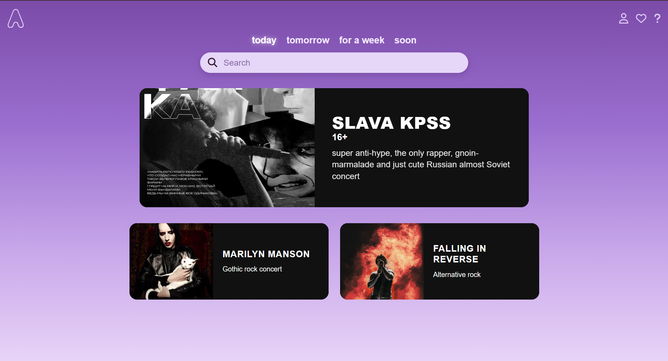

Мобильная адаптация:
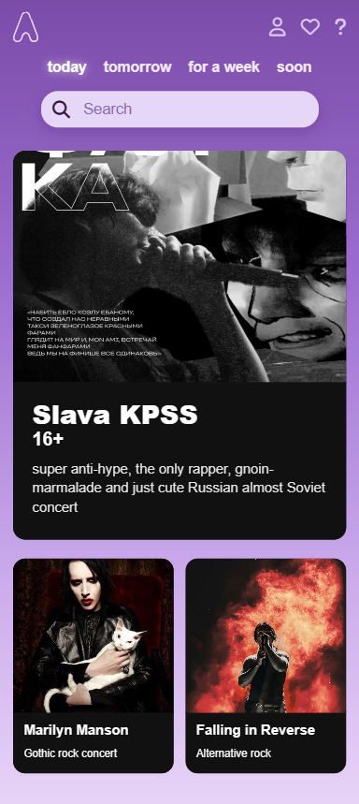

Окно профиля (profile.html):
Десктоп:
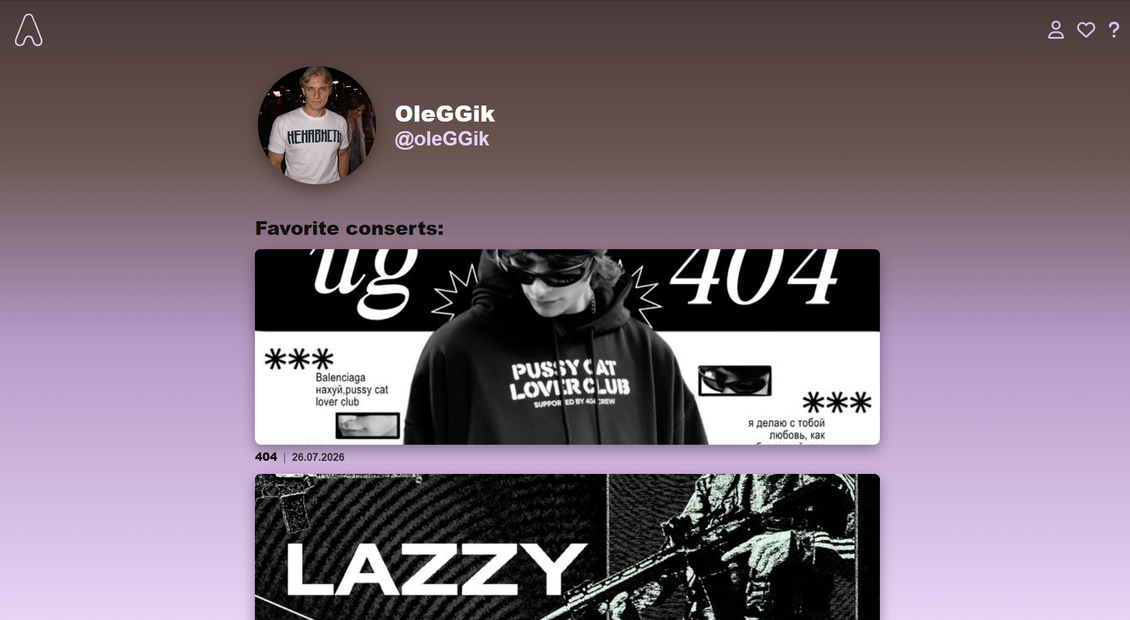

Мобильная адаптация:
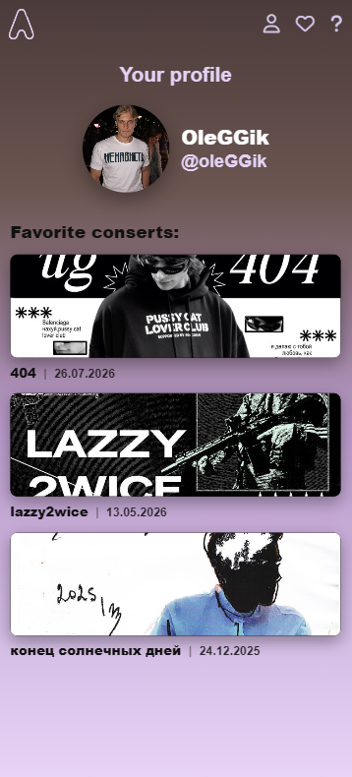

Окно мероприятия (fallinginreverse.html, slavakpss.html, marylinmanson.html):
Десктоп:
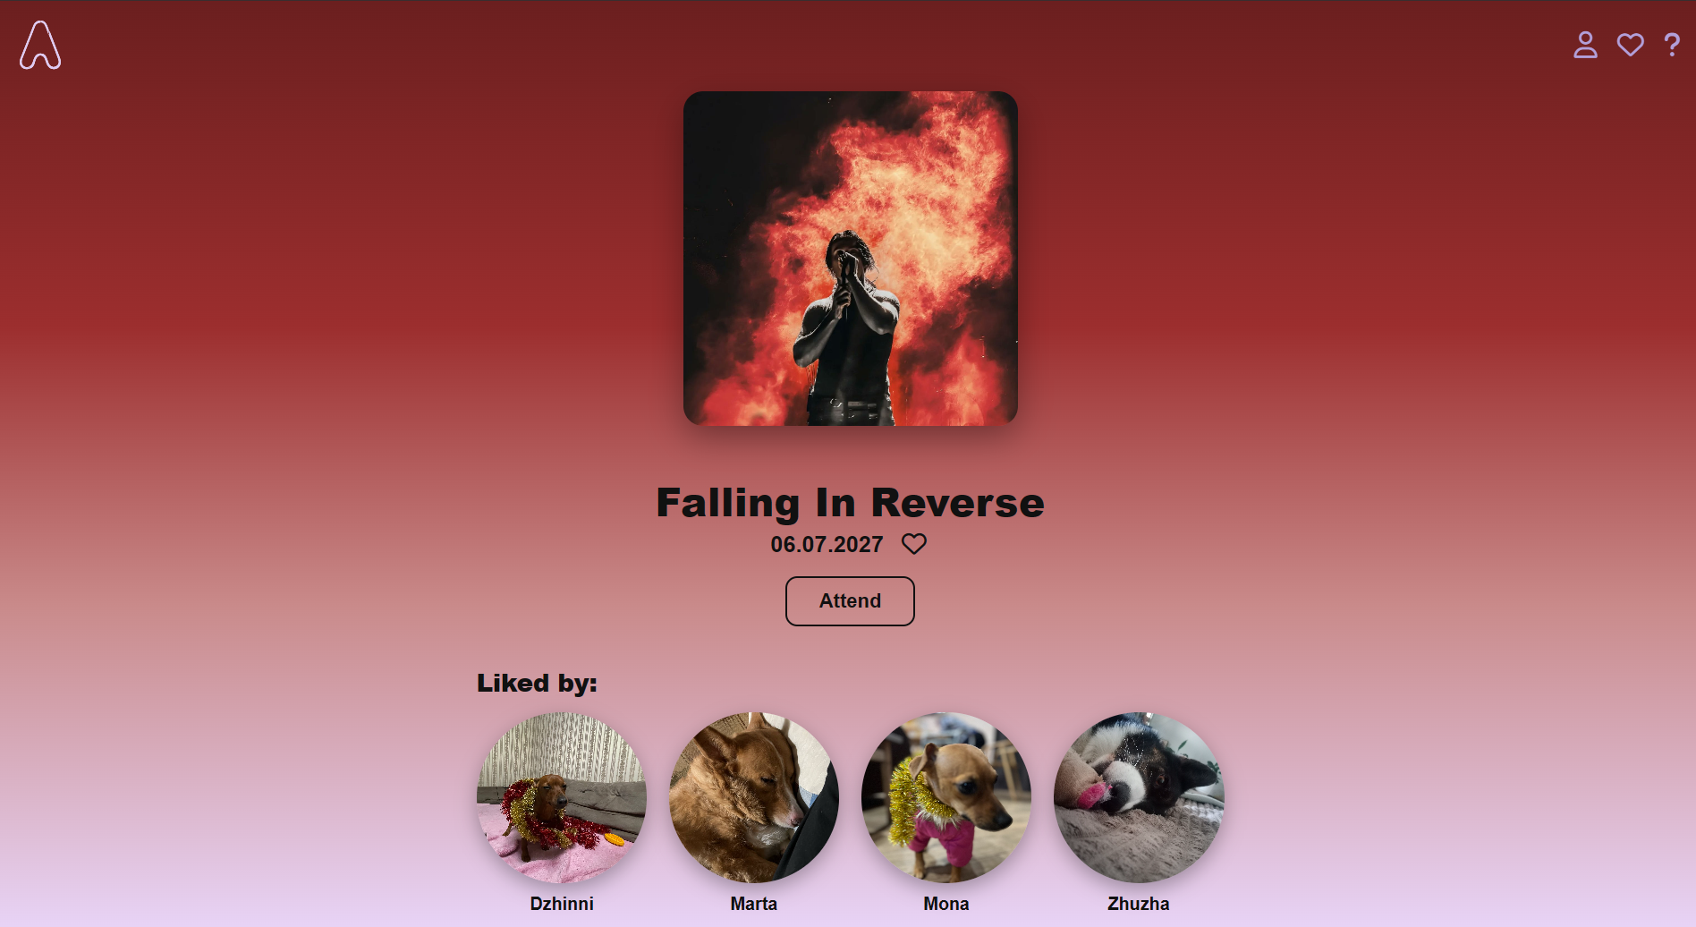
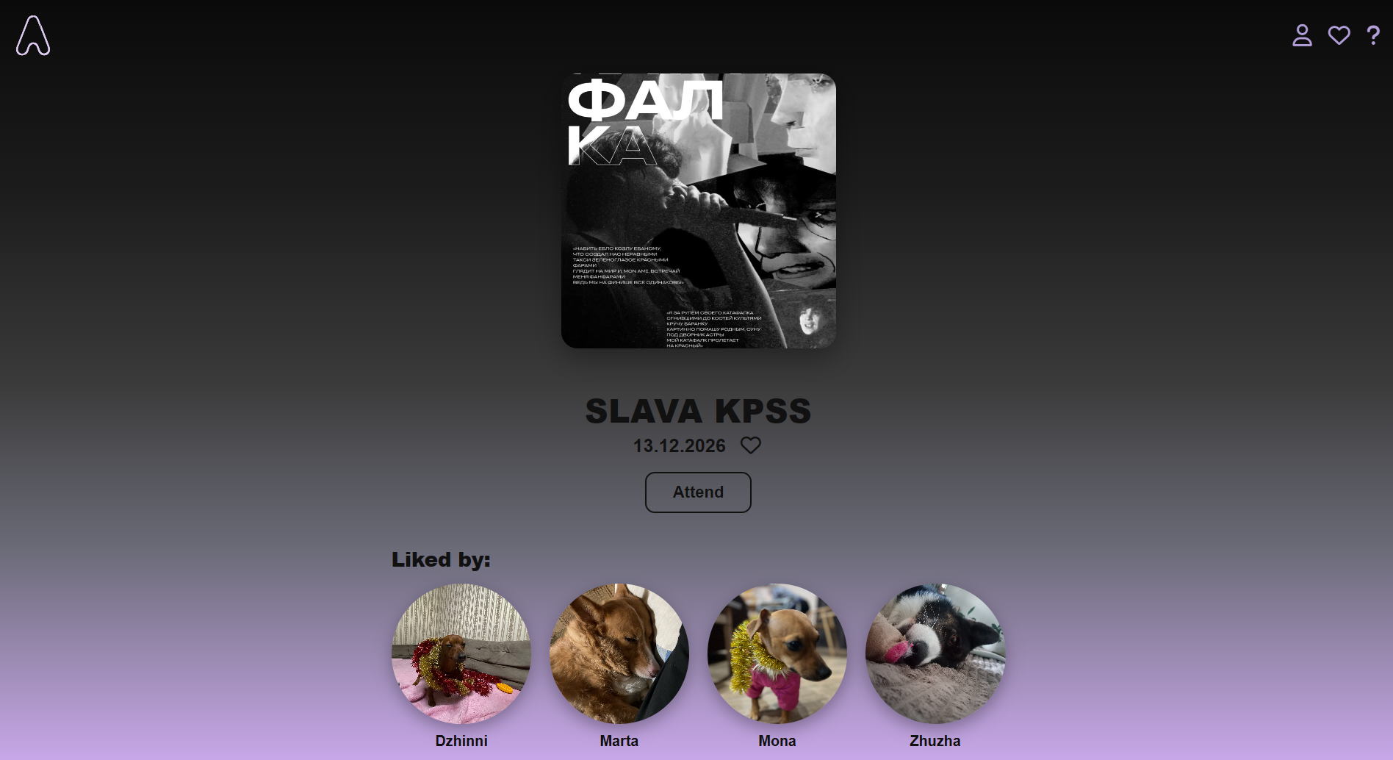
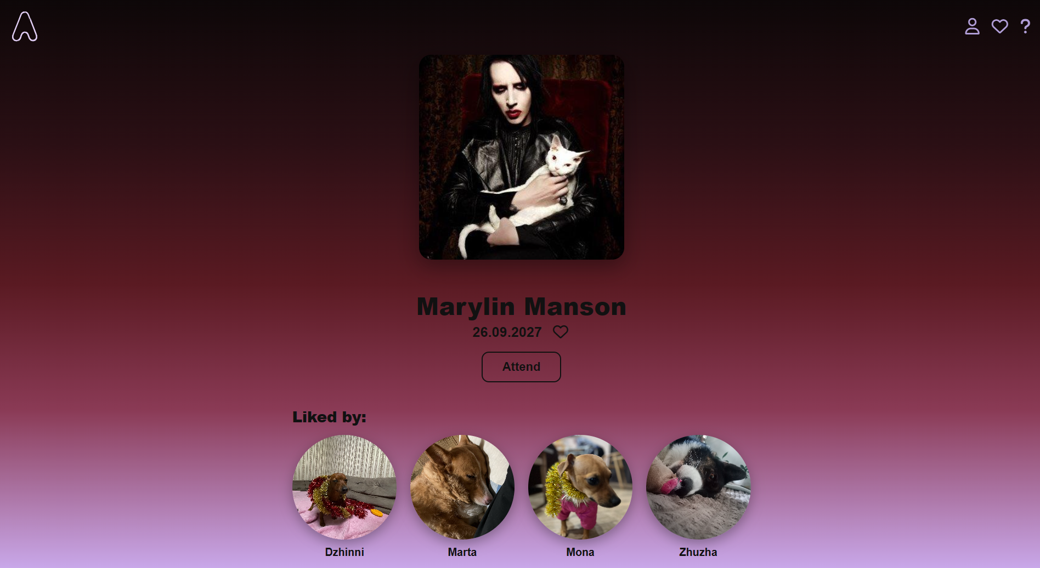

Мобильная адаптация:
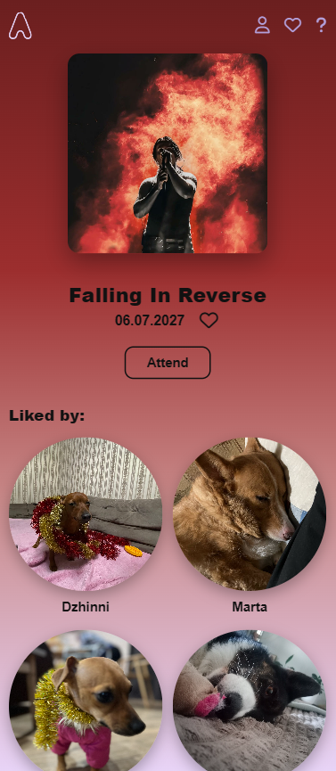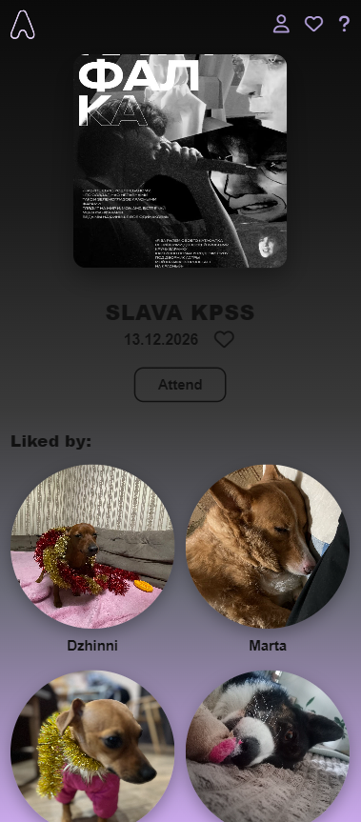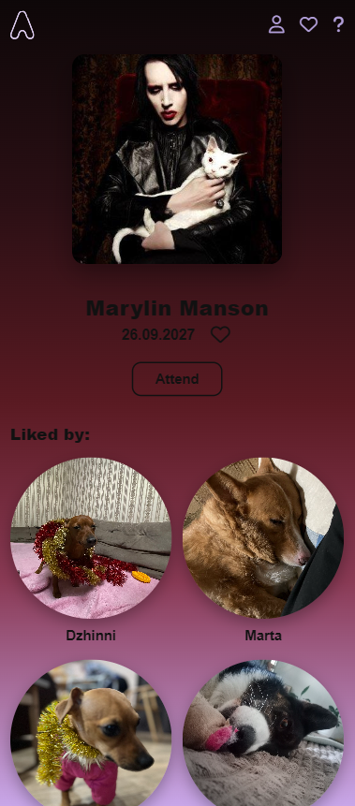

Контрольные вопросы:
1. Оптимизация интерфейса под мобильный UI/UX. Что это означает.
Оптимизация интерфейса под мобильный UI/UX означает приведение внешнего вида и поведения сайта в соответствие с особенностями небольших экранов и сенсорного ввода. Это предполагает использование достаточно крупных кнопок, размер которых не меньше 44 пикселей, шрифтов размером от 16 пикселей для хорошей читаемости, сокращение количества элементов на экране, организацию навигации, удобной для управления одной рукой, обеспечение быстрой загрузки и выстраивание понятной структуры, не требующей лишних переходов между страницами.

2. Каким образом можно устранить различия в мобильных браузерах.
Устранить различия в отображении между мобильными браузерами можно с помощью CSS-reset или normalize.css. Эти инструменты приводят стандартные стили, такие как отступы, шрифты и размеры, к единому виду во всех браузерах. Дополнительно помогает подключение метатега viewport и использование вендорных префиксов для CSS-свойств, что обеспечивает более предсказуемое поведение вёрстки.

3. Что означает стратегия Mobile First.
Стратегия Mobile First подразумевает, что проектирование и вёрстка начинаются с мобильной версии интерфейса, а стили для больших экранов добавляются позже с помощью медиа-запросов с min-width. Такой подход даёт лучшую производительность на телефонах, позволяет писать более чистый код и концентрирует внимание на главном содержимом страницы.

4. Что такое медиа-запросы. Примеры медиа-запросов.
Медиа-запросы ‒ это правило CSS @media, которое применяет стили только тогда, когда выполняется заданное условие, например определённая ширина экрана или его ориентация. В качестве примеров можно привести запись @media (min-width: 768px), внутри которой для класса .books задаётся grid-template-columns: repeat(3, 1fr), запись @media (max-width: 480px), где для .header устанавливается flex-direction: column, а также @media (orientation: landscape), при которой для .footer используется display: none.

5. Что такое минификация файлов веб страниц
Минификация файлов веб-страниц ‒ это удаление из HTML, CSS и JavaScript всех лишних символов, включая пробелы, переносы строк и комментарии, а также сокращение имён переменных. Это уменьшает размер файлов и ускоряет загрузку страницы. Например, файл style.css до минификации может занимать 8 КБ, а после неё ‒ 5 КБ.

